Steps for Waltti automation Setup:

- Download & install Python 2.7.8 “python-2.7.8.amd64.msi”

- Download & install wxpython “wxPython2.8-win64-unicode-2.8.12.1-py27.exe”

- Set Below Environment Variables
System Variables: in Path append the following
C:\Python27\Scripts;C:\Python27\Lib\site-packages;
User Variables: Give new PYTHONPATH as
C:\Python27\Lib\site-packages;
- Go to cmd and verify whether it has installed successfully by below command
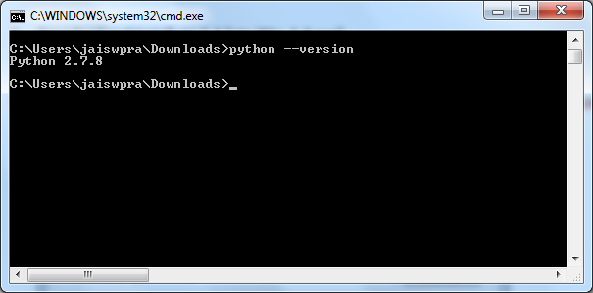

- Download and install pip 1.4 “pip-Win_1.4.exe”

- Install Robot Framework, Selenium2Library, Robot Framework IDE and DatabaseLibrary by below commands through PIP

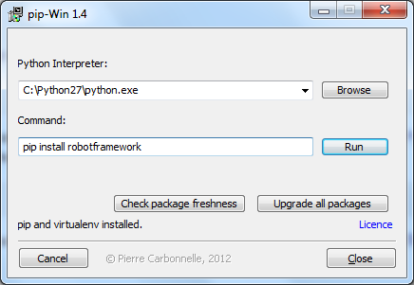

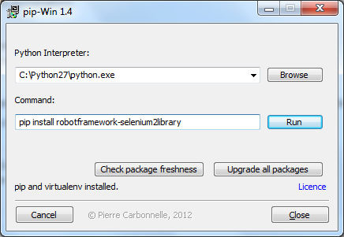

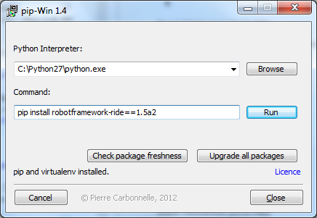

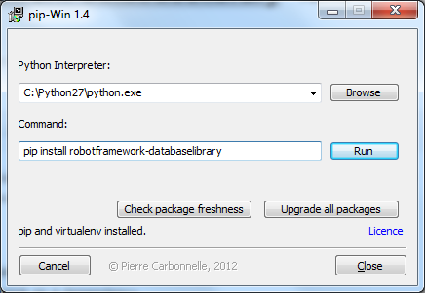

Verify whether Robot Framework has installed properly by below command

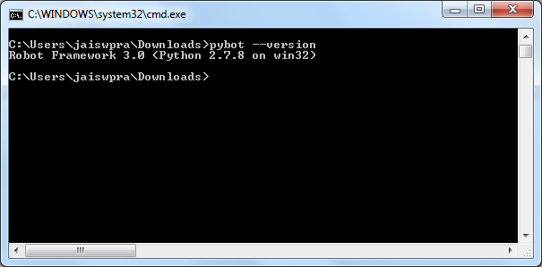

- Now Download & install “pip install mysql-connector-python
” ( Waltti Specific)

- Lastly Download & install “pip install mysql-connector-python
” ( Waltti Specific)

